Trail-O Meeting Primorska, 18. and 19.6.2011
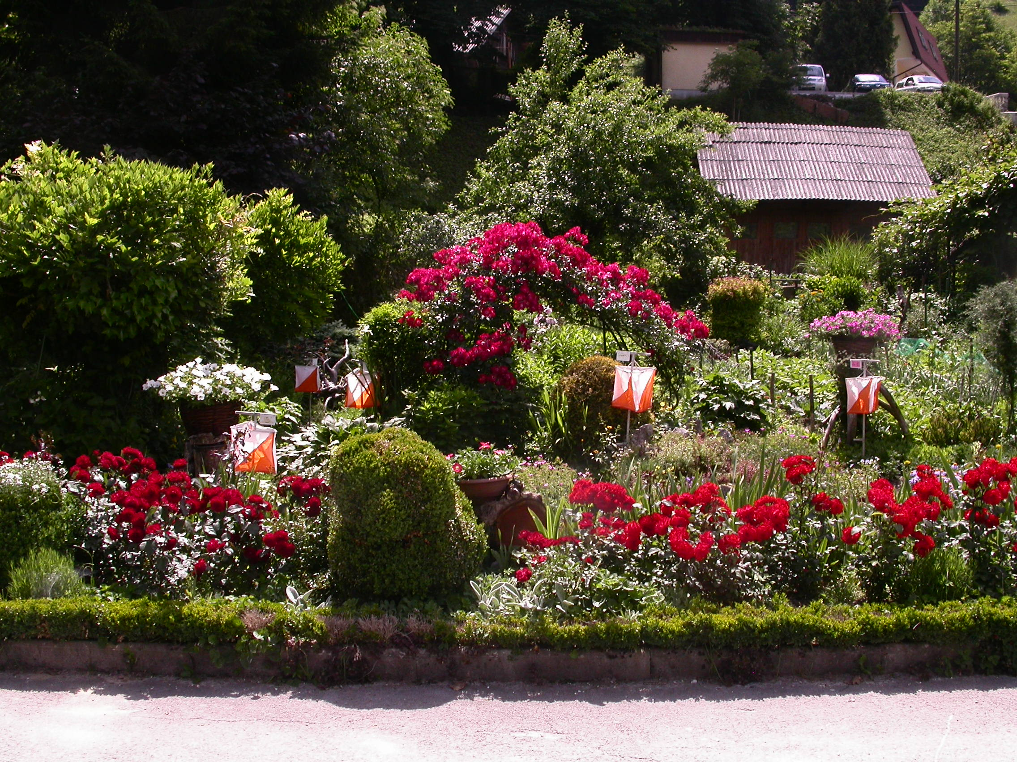

SOME IMPORTANT INFORMATIONS FOR THE PARTICIPANTS

1.The parking on Saturday will be along the forest road near the meeting point, close to the start.

2. For the parking on Sunday you will get the instructions at registration on Saturday. On Sunday the Competition center, Start and Finish will be at the same place in front of the Elementary school – Osnovna šola Idrija.

3. The courses:
Blatnice, 18.6.2011
category | lenght | controls
E | 970 m | 18+3
A | 970 m | 12+2
N | 970 m | 8+1

Idrija, 19.6.2011
category | lenght | controls
E | 2360 m | 20+3
A | 2360 m | 16+2
N | 2360 m | 11+1

4. There are 24 competitors entered. See the start list below. Little changes are possible.

5. Additional informations on phone 041 360 840.

We wish you a nice TrailO weekend.

Tiziana, Cesare, Emil and Vlado



